Mr. Conkle’s Summer Homework
Math
Part 1:
Review skills: Word Problems, money, place value, Addition & Subtraction, Multiplication, Fractions, and Ratios
1) Write the place value of the 8 in the following numbers.
_____________ 8,456
_____________ $85.45
_____________ 38
_____________ 38,945,233
2) Add or Subtract:
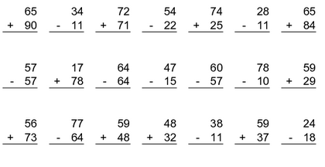
3) Use the following items to write a ratio.

_____:_____ ratio of stars to triangles
_____:_____ ratio of triangles to stars

_____:_____ ratio of stars to all shapes
_____:_____ ratio all shapes to triangles

4) Tell what part of each figure is shaded.
____________ ____________ 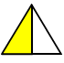 ____________

5) Find the answer

____________ Mr. Conkle wants to buy a new video game. The game costs $49.99. He has saved
up $34.50, how much more money does Mr. Conkle need. (Show work)

____________ In order to gain some more money, Mr. Conkle has decided to sell some of his old
games. He has 6 old games. If Mr. Conkle keeps 3 of those games and sells the others
for $12 each, how much money will he get? (Show work)

____________ Mr. Conkle has five more action games than he has sports games. He has one less
puzzle game than he has sports games. If he has three sports games, how many
games does he have in all? (Show work)

Part 2:
Review skills: Word Problems, Money, place value, Addition & Subtraction, Multiplication, Graphs /Grids/and Charts, and Measurements
1) Subtract to find the answer
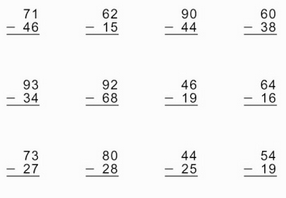
2) Use a ruler. Measure the lines to the nearest inch.
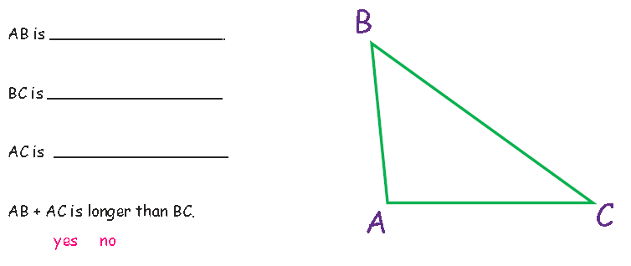3) 3) Find the answer. (Show all work)
Mr. Conkle likes to eat cheeseburgers. A single cheeseburger costs $1.25 and a double
Cheeseburger costs $2.00. If Mr. Conkle’s wife gives him 50 cents an hour to work in
the yard, how many hours will Mr. Conkle have to work to buy a single cheeseburger?
A double cheeseburger?
_______________ Single Cheeseburger _______________ Double Cheeseburger
4) Add or Subtract.
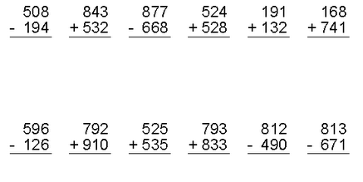
5) Use the bar graph below to answer the questions.
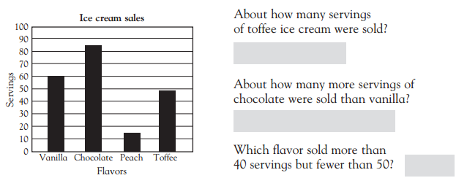
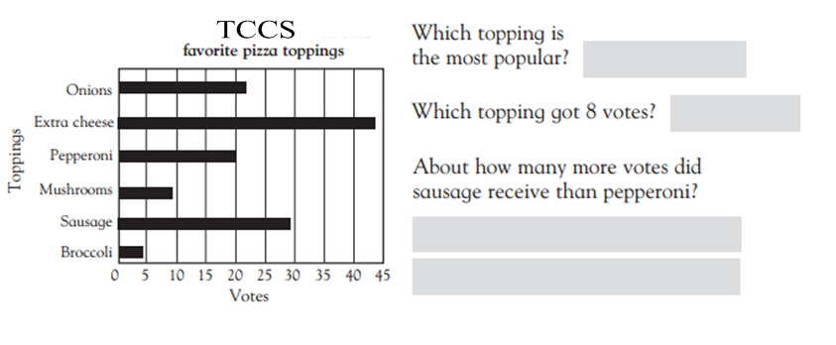
6) Magic Square
Directions: Fill in each square. Use the numbers 1 through 9. Use each number only once per square.
The numbers must total 15 when they are added together horizontally and vertically. There are many
ways to solve this puzzle. One is done for you. Complete the second.
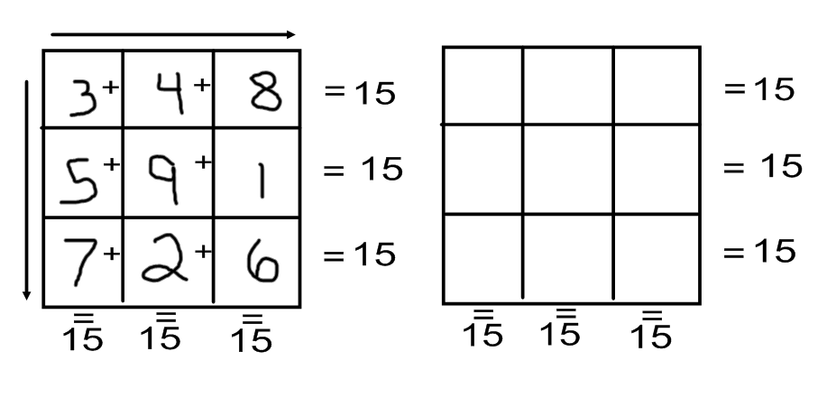
Part 3:
Review skills: Word Problems, Money, Multiplication, Graphs /Grids/and Charts, Perimeter and Area, and Measurements
1) Area and Perimeter (*Remember: Perimeter is the distance around something. Area is the space
inside the object.)
What is the area and perimeter of the following shapes?
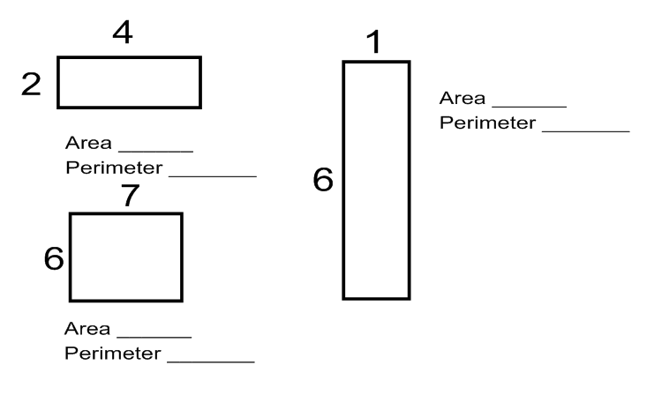

2) Multiply. Show all work.
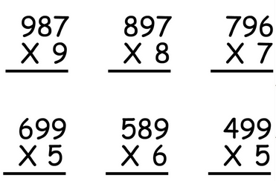

3) Complete the input/output chart. Write the rule for each.
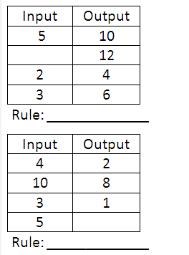
4) Find the answer. Show all work.
Mr. Conkle likes to run. He can run from his house to the school in 10 minutes, from the
from the school to John’s house in 12 minutes, from John’s house to the mall in 7 minutes
and from the mall to back to his house in 17 minutes. How long will it take him to run the
entire trip?
_____________________

Mr. Conkle wants to go to the movies with his friends to see Iron Man 3. The movie ticket
costs $7.50. When he gets to the movies, Mr. Conkle orders small popcorn that costs
$4.35 and a bottle of water for $1.95. Mr. Conkle paid for everything with a $20 bill. How
much change will he receive?
_____________________

Mr. Conkle’s son, Ben, is 48 inches tall. His daughter, Lauren, is 9 inches shorter than Ben.
His nephew, Nick, is 16 inches taller than Lauren. How tall is Nick?
_____________________

5) Buried Treasure!
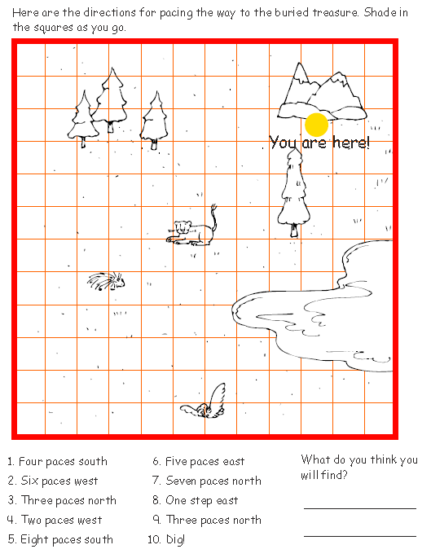

Part 4:
Review skills: Sequencing, Number Words, Word Problems, Division, Graphs /Grids/and Charts, Measurements, Tell Time
1) Divide. Show all work
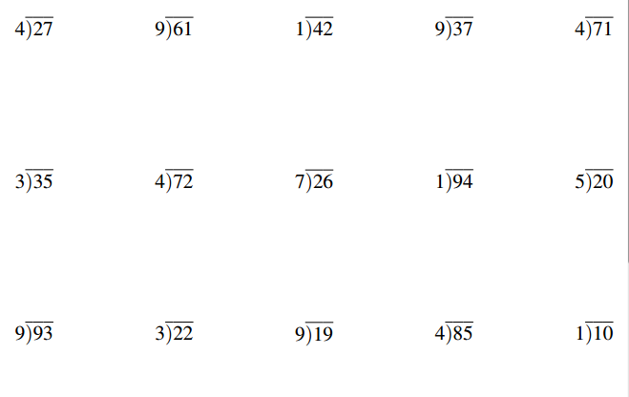
2) Write the following numbers in Standard Form.
________________ five hundred twenty-seven
________________ eleven thousand, four hundred four
________________ twenty-three thousand, fifteen

3) Write the following numbers in Word Form.

364 ________________________________________________________________

1,089 ________________________________________________________________

18,308 ________________________________________________________________
4) Find the coordinates.
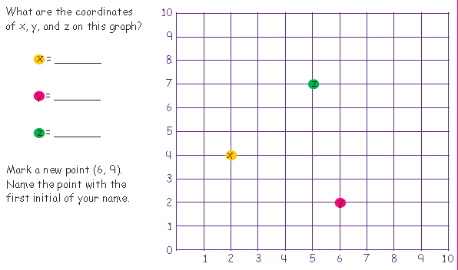
5) Order these numbers from Least (smallest) to Greatest (largest)
7.34 73.4 70.34 73.04
_____________ ; _____________ ; _____________ ; _____________

87,345 87,354 8,999 89,549
_____________ ; _____________ ; _____________ ; _____________

6) Compare. Put > (greater than), < (less than), or = (equal to) on the line.

3.09 ____ 3.11 2.3 ____ 2.30 5 + 10 ____ 3 x 4

12.465 ____ 1.897 24 – 12 ____ 36 – 24

7) Find the answer. Show all work.
Mr. Conkle bought a 2 pound (lbs.) steak to share with his wife for dinner. How many
ounces (oz.) of steak did Mr. Conkle buy? (hint 16 oz. = 1 lb)
_____________________

Mr. Conkle started playing video games at 3:45 pm. He played for 1 hour and 25 minutes.
What time did he stop playing video games?
_____________________

What is the largest number you can create using the following digits? _____________
2, 4, 6, 1, 8, 9
What is the smallest? ___________________

Part 5:
Review skills: Patterning, Word Problems, Money, Addition, Subtraction, Multiplying, Dividing, Fractions, Tell Time, Shapes and Angles, Mean/ Median/ Mode/ Range.
1) Add
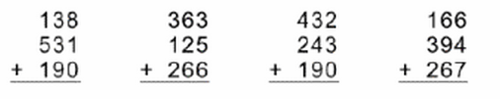
2) Subtract
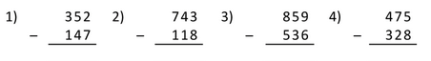
3) Multiply. Show all work.
58 x 4 = ___________ 32 x 4 = ___________ 61 x 7 = ___________

4) Divide. Show all work.

5) Continue the patterns.
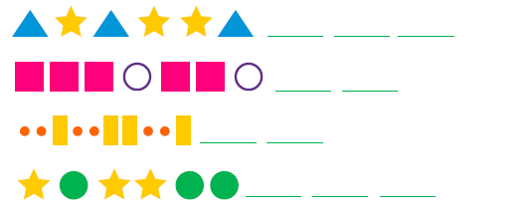
6) Find the answers. Show all work.
Mr. Conkle can run a mile in 9.5 minutes. If he could keep this pace up for 5 miles
(and that’s a big if), how long would it take him?
_________________

TCCS is selling T-shirts for School Spirit week. Each shirt costs $12. If the school makes
$3 per T-shirt, how much money will they make if 23 T-shirts are sold?
___________

7) Add like denominator fractions. Put answers in simplest form.
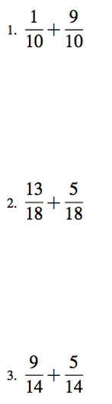

8) Find the Median of each set of numbers.
4; 6; 8; 11; 15; 24; 35 _____________________
6; 12; 14; 21; 23; 24 ______________________
3; 9; 4; 7; 1; 9; 2 ______________________

Part 6:
Review skills: Word Problems, Place Value, Addition, Subtraction, Dividing, Graphs/ Grids/
and Charts.
1) Find the answers.
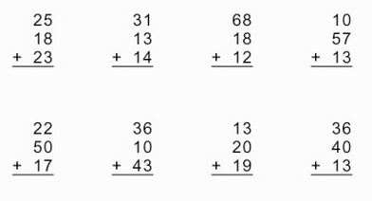

2) How many containers will you need if…? Complete the following chart to find out.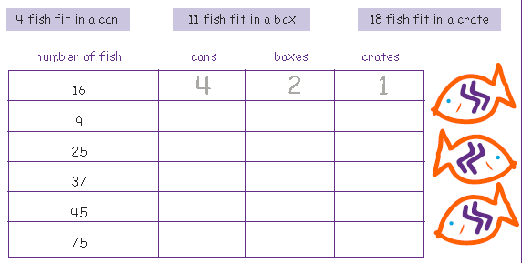

3) Find the answer.
In the number 24,582, what digit is in the
Tens place _____________
Ten thousands place _____________
Ones place _____________
In the number 736.8152, what digit is in the
Tens place _____________
Tenths place _____________
Hundredths place _____________
4) Find the answer. Show all work.
Mr. Conkle’s family will start their trip to the zoo at 8:45 A.M. Breakfast will take 45 minutes.
They plan to stay at the zoo for 2 hours. Lunch will take another 45 minutes. What time
will it be when Mr. Conkle’s family finishes lunch?
_________________

Mr. Conkle’s son, Ben, and his friend, Adam, collect baseball cards. Adam has three times as many cards as Ben. Ben has 78 cards. How many cards does Adam have?
_________________

5) Solve. Show all work.
987 + 682 + 319 = _______________ 297 + 374 + 97 = _______________

Part 7:
Review skills: Word Problems, Money, Addition, Subtraction, Division, Fractions, Measurement, Tell Time, Shapes and Angles, Decimals.
1) Find the Quotient. Show all work.
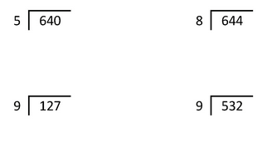
2) Find the answer. Show all work.
Mr. Conkle’s daughter has 15 stuffed animals. If she gives 1/3 of them to her friend, how many
stuffed animals will she have left?
______________

Lauren is trying to earn some extra money, so she can purchase another stuffed animal. The
one she wants is $21.00. She has decided to walk the neighbor’s dog for him. He has agreed
to pay her $2.25 each time she walks his dog. How many times will she have to walk the
neighbor’s dog in order to buy the stuffed animal?
______________

3) What is the perimeter of each shape?
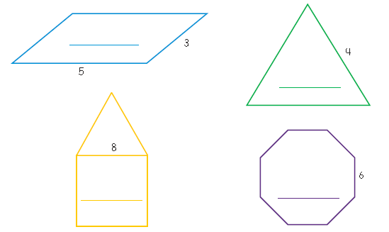

4) Find the answers. Show all work.
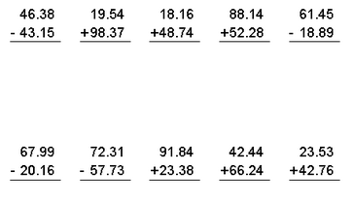

5) What time is shown on each clock?
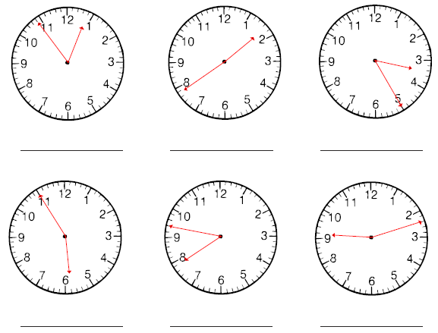
6) Find the answer. Show all work.
President Lincoln’s speech, The Gettysburg Address, began with the words: “Four score
and seven years ago…” If one score is 20 years, how many years is Four score and seven?
________________

Mr. Conkle’s daughter plans to spend three hours and ten minutes on her science project. She
must be finished by 8:00 p.m. What time must she start?
________________

Part 8:
Review skills: Word Problems, Money, Division, Measurement, Tell Time, Shapes and Angles, Graphing.
1) Find the answer. Show all work.
Mr. Conkle’s daughter had a sleepover party. It ended at 11:30 a.m. Saturday. If the party
lasted 16 hours and 30 minutes, at what time did the party start?
________________

Mr. Conkle loves Snicker Bars. He can go to Walmart and buy them for $0.70 each. At
Giant Eagle he can buy 3 of them for $2. Which is the better buy and Why?
________________
Why: _____________________________________

2) Multiply. Show all work.
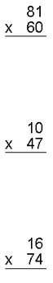
3) Name each shape. Count the sides (edges) and corners (vertices). Then classify (name)
each shape.
Edges: _______ Vertices: ________
Classify: _____________________

Edges: _______ Vertices: ________
Classify: _____________________

Edges: _______ Vertices: ________
Classify: _____________________

4) Find the answers. Equals 8
+ 14 = ____ 40 - = ____ 74 – 2 = ____

9 + = ____ 0 + 2 = ____

5) Fill in the chart.
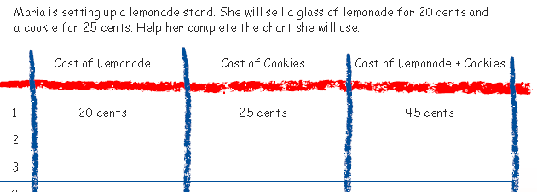
6) What is it?
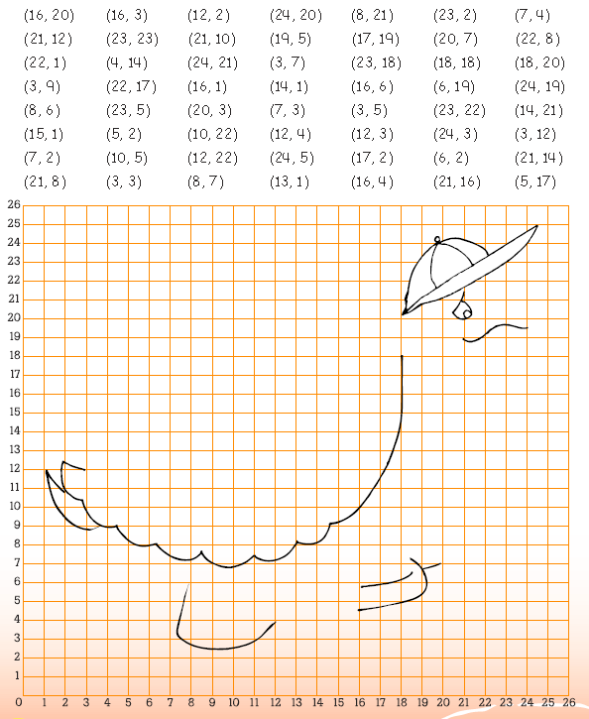

Part 9:
Review skills: Word Problems, Money, Multiplication, Measurement, Mean, Median, and Range.
1) Tell how much for each one. Show all work
2 pencils for $1 1 pencil __________

$15 for 3 rulers 1 ruler __________

8 pens for $3.20 1 pen __________

2) Find the answers. Show all work.
Mrs. Conkle is putting away dishes. She can only place five dishes in each stack into the
cupboard (or they will break!). If she has 17 dishes to put away, how many stacks of dishes
will be placed into the cupboard?
______________________

Mr. Conkle loves to ride rides at the local fair. If each ride costs 50 cents, how much money will
he need to ride all 17 rides?
______________________

3) Multiply to find the answers.
Ex. 3(4) = _____ This means 3 x 4 = so the answer is 12
7(8) = _____ 4(9) = _____ 6(5) = _____ 12(12) = _____

4) Choose the correct answer.
Mr. Conkle’s son weighed 9 lbs. 6 oz. at birth. At age 3 months, he weighed 13 lbs. 10 oz.
How much weight did he gain in three months?
4 lbs. 2 oz. 4 lbs. 12 lbs. 9 oz. 4 lbs. 4 oz.

A full jar of peanut butter weighs 1000 grams. An empty jar of peanut butter weighs 30 grams.
How much peanut butter does the jar hold?
1030 grams 970 grams 930 grams 30,000 grams

5) Find the answers. Show your work.
How many inches are in 3 feet? (Hint: 1ft. = 12 in.)
____________

How many yards are in 12 feet? (Hint 1 yd. = 3 ft.)
____________

How many inches are in 2 yards?
____________

6) Find the Range of the following numbers.
14; 56; 62; 125; 230
____________

Part 1:
Review skills: Word Problems, Money, Addition, Multiplication, Measurement, Tell Time, Common Factors
1) Find the answers. Show all work.
During basketball season, Mr. Conkle’s daughter scored at least one point in half of her games.
If she played in 12 games, in how many games did she score at least one point?
__________________

Mr. Conkle is baking cookies for his class. Each batch of cookies makes 14 individual cookies.
His class has 30 students. How many batches of cookies does he need to make in order for each
student to get at least 1 cookie?
__________________

Ben’s dresser has 6 drawers in it. In each drawer he jams in 4 stuffed animals. How many
stuffed animals did he put into his dresser?
__________________

2) Write the correct letter(s) to describe each pair of lines.
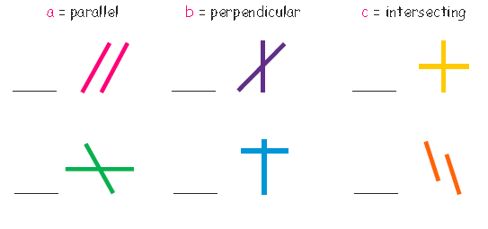
3) Write the answer
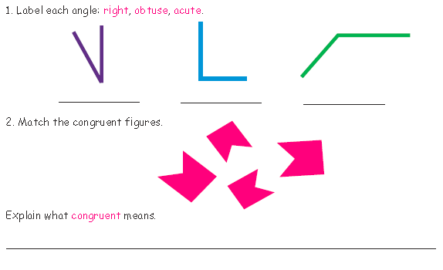
4) Find the answer.
The 5th Grade begins class at 8:00 am. The school day ends at 3:11 pm. How much
time do we have each day in school?
___________________

Each grading period in school is 90 days. About how many months is that?
___________________

Mr. Conkle bought some cool prizes from Oriental Trader. Mrs. Conkle allows him
to spend up to $100.00. His order came to $93.54. How much money does he have
to spend?
___________________

5) Find the answers.
What are the common factors of 8 and 20?
___________________

What are the first 3 multiples of 5 and 6?
5- _____ _____ _____
6- _____ _____ _____
List all the Factors of 12.
___________________

