Utterly Fascinating Theories Behind The Vanishing Roanoke Colony

Lyra Radford
The disappearance of the Roanoke colony remains one of the oldest unsolved mysteries in the United States. It all began back in 1587, when Sir Walter Raleigh financed the attempts of John White to establish a colony on Roanoke Island, just off the coast of North Carolina. They landed on July 22, establishing themselves rather quickly, and everything seemed to be going well for the thriving colony of 115 people. In fact, John White’s daughter, Eleanor Dare, gave birth to a daughter while in Roanoke. Little Virginia Dare was born on August 18th and has the title of being the very first English child born in the Americas.
John White set sail back to England to gather fresh supplies, but an attack by the Spanish Armada delayed his return. White finally returned to Roanoke in 1590 after being away from his family for three years, but he arrived to find the entire colony had simply vanished, leaving nothing behind except the word “Croatoan” carved into a post and “Cro” etched into a tree. But what does "Croatoan mean" and where could the colony have gone?

The Colonists Were Absorbed Into Local Native Tribes as Friends or Slaves
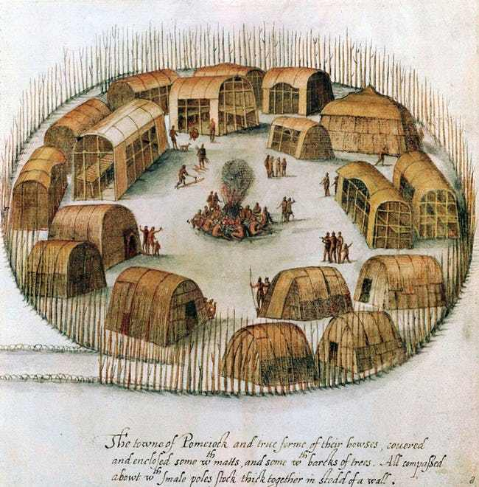Photo: Public Domain/via Wikimedia Commons
Just south of Roanoke was an island named Croatoan that was home to a Native American tribe of the same name. Since the settlers had developed a good rapport with the tribe and the name “Croatoan” was found, it was assumed the settlers must have moved to the island of Croatoan and been absorbed into the tribe or simply moved inland, perhaps driven off by Spanish troops. Some theorize they moved north to join the Chesapeake tribe, or perhaps the Chowanocs or Weapemeocs, among many others.
There were many sightings of Europeans and European-made goods in the area in the years following the colony's disappearance, though most were hearsay. The "Zuniga map, a map of the area drawn about 1607 by a settler from Jamestown, states "four men clothed that came from roonock" were living among the Iroquois. Another English man claimed the had seen two-story stone houses at the Indian settlements of Peccarecanick and Ochanahoen; supposedly, English settlers had taught them how to build such houses.
Contemporary archaeologists have found some more verifiable evidence, including a gold signet ring, part of a rapier, and a slate and pencil that may have belonged to the Roanoke colonists living among Native people.
It is also possible the colonists met with Native people who were less friendly. The contemporary historian William Stachey reported seeing Native tribes with European slaves, who were forced to beat copper.
To this day, many Native people in the region claim to have European ancestry. However, a DNA analysis of present-day local families that hoped to prove the people of Roanoke intermingled with Native people in the area has so far proven inconclusive.

The Colonists at Roanoke Were the Victims of Cannibalism - Or Practiced It Themselves
Photo: John White/via Wikimedia
There were other tribes in the area that weren’t as friendly as the Croatoan tribe. There was a theory that one of these more aggressive groups, who may have been cannibals, attacked and ate the English colonists. The lack of bodies could just mean there was nothing left: many cultures have used bones as ingredients for healing remedies, grinding them into a powder form. It may sound like a time-consuming task, but it took three years for White to find out they were missing. There’s no way to know exactly when the settlers started disappearing – they could have been picked off one by one.
There is no evidence that any tribes in the area practiced cannibalism; there is, however, evidence that the colony of Jonestown, Virginia, committed cannibalism in 1609. It’s quite possible their predecessors over in Roanoke succumbed to eating human flesh as well. After their leader left for supplies and didn’t return for three years, they could have been starving. There was also talk from local tribes that the colonists were having a war within their ranks. The people of Roanoke could have resorted to cannibalism and eaten themselves out of existence.
Or perhaps some of them still exist, taken over by the ancient Native American spirit of the wild, known as a wendigo - it was believed that when a human resorted to cannibalism to survive, they might turn into the terrifying beast.

The Word Appears at the Site of Many Other Mysterious Disappearances
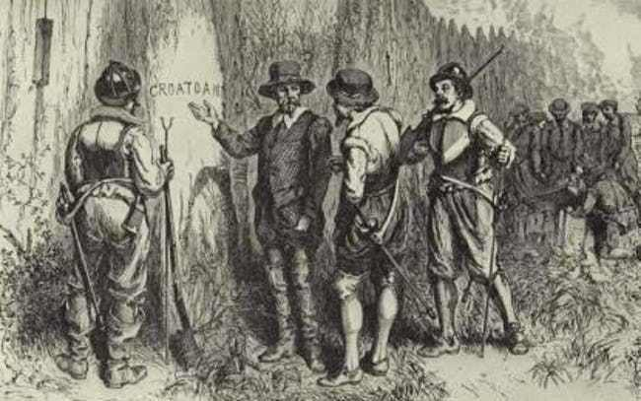Photo: Public Domain/via Wikipedia
This mysterious word was also found scribbled in the journal of Amelia Earhart after her disappearance in 1937. Horror author Ambrose Bierce vanished in Mexico back in 1913. The bed he slept in last had the word "Croatoan" carved in its post. The notorious stagecoach robber Black Bart etched the word into the wall of his prison cell right before his release in 1888 and was never seen again. "Croatoan" was written on the last page of the logbook of the notorious ghost ship Carroll A. Deering back in 1921, when it ran aground on Cape Hatteras (missing its crew), right by what was once known as Croatoan Island.

They Were Massacred by Chief Powhatan
Photo: Public Domain/via Wikimedia Commons
In 1607, members of the Jamestown Colony attempted to uncover the fate of their unfortunate predecessors. John Smith, the Jamestown colony's founder, claimed that the Native chief Powhatan had confessed to him that he had murdered the colony as payback for them aligning themselves with a rival tribe. Supposedly Powhatan showed Smith some items he had taken from the colonists, including a musket barrel and a brass mortar and pestle. However, contemporary historians and anthropologists dispute this story.

An Infectious Disease Drove the Colonists Mad
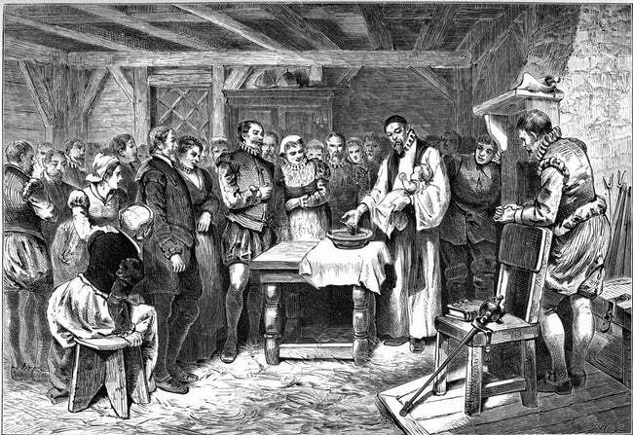Photo: Henry Howe/via Wikimedia
Because of the reports from Native American tribes claiming to have witnessed internal warfare among the Roanoke colonists, archeologists have also theorized that the Roanoke settlers could have contracted a plague. The illness could have caused delirium, paranoia, or even complete madness amongst the infected. Perhaps those not infected wanted to rid themselves of those who were out of fear of contracting the virus themselves. This type of “us-or-them” scenario could have easily escalated into violence, murder, and even cannibalism.

The Colonists Were Murdered by Spanish Troops
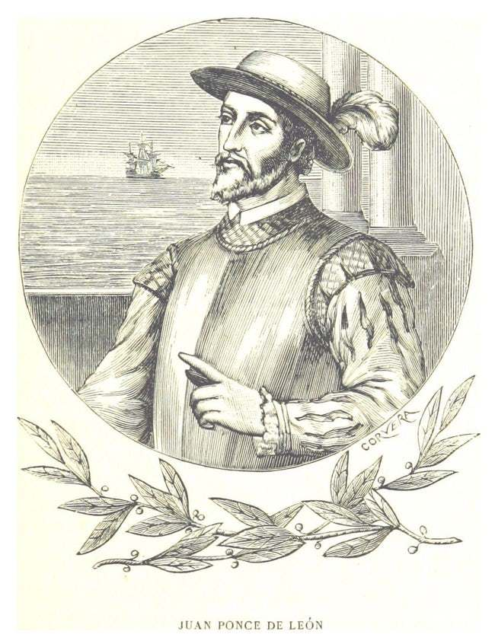Photo: Public Domain/via Wikimedia Commons
England was at war with Spain during the time the Roanoke colony disappeared (in fact, this is what delayed Governor White's return to the colony), and some think that Spain was involved in their disappearance. Spanish troops were present in Florida at the time, and Spain and England were locked in a rivalry over the colonization of the Americas, among other things. Did Spanish troops make their way up to North Carolina to eradicate an English foothold in the area?

The Colonists Were Sabotaged as Part of a Plan to Discredit Sir Walter Raleigh
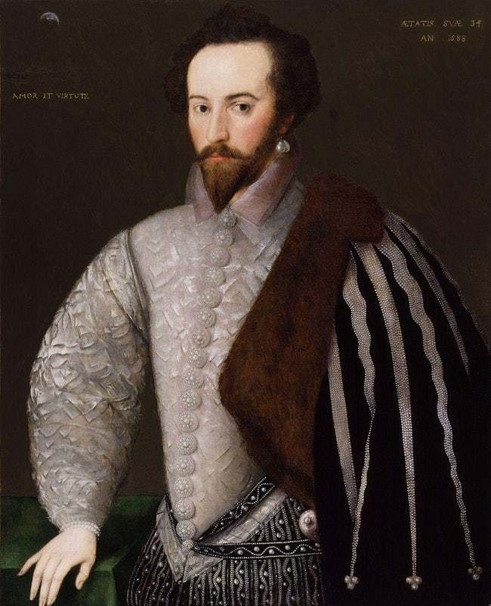Photo: 'H' monogrammist (floruit 1588)/via Wikimedia Commons
Anthropologist Lee Miller believes that the colonists were the victims of a plot by Sir Francis Walsingham, Queen Elizabeth I's secretary of state. According to her book Roanoke: Solving the Mystery of the Lost Colony, Walsingham intentionally stranded the colonists and left them to die because he "wanted to bring down Raleigh, the Queen's golden boy who had received a royal patent to all land he could settle in the New World."
Lee argues that the colonists moved west into the interior of the state, where they became embroiled in a conflict between warring Native tribes and many were killed or taken captive as slaves. All of this was intentionally kept secret by the Crown, which explains why no records exist.

The Colonists Tried to Sail Back to England
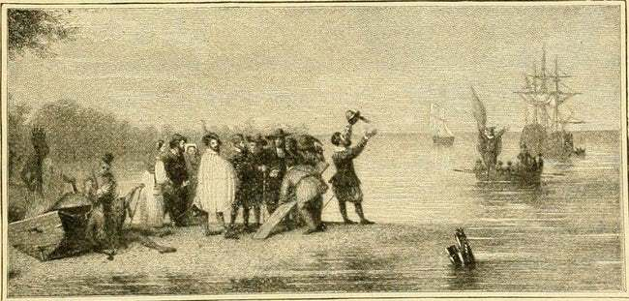Photo: Internet Archive Book Images/flickr/No known copyright restrictions
It has also been theorized that they grew tired of waiting for John White to return and attempted to sail back to England on their own. Unfortunately, there is no ship, shipwreck, or evidence of any kind to support this theory, either.

The Croatoan Tribe Executed the Colonists as Suspected Witches
Photo: Santiago Camado/via Wikimedia Commons
The Croatoan tribe encountered by the Roanoke colonists believed in witches, both males and females that used black magic to do evil - including, for example, things the colonists may well have been doing, both intentionally and otherwise, including spreading diseases. While the local tribes in that area did not regularly execute witches, there is some precedence for them putting dangerous outsiders to death - and the colonists were nothing if not dangerous outsiders.

Roanoke Was the Site of a Zombie Apocalypse
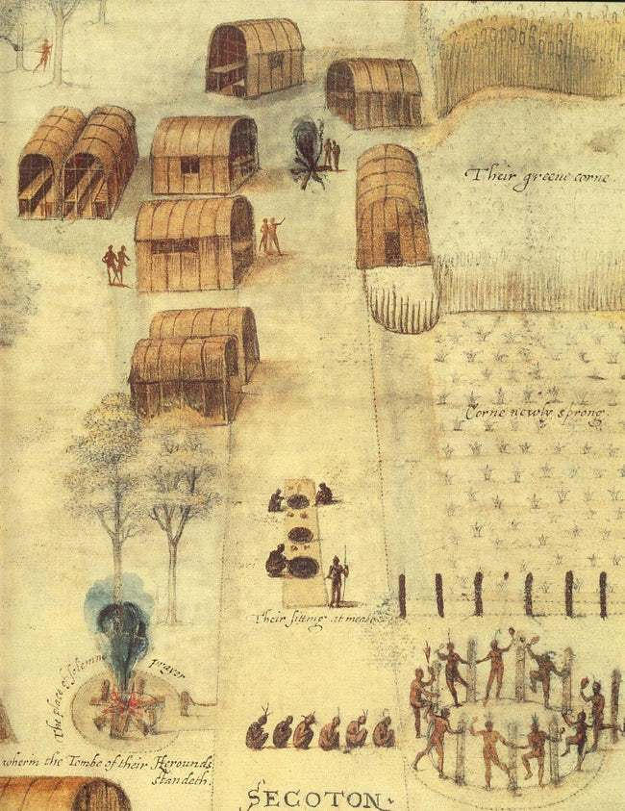Photo: John White/via Wikipedia
Another theory folks like to share on the Internet is that Roanoke was ground zero for some kind of zombie apocalypse. This theory combines the disease theory with the cannibalism theory. First, the settlers were infected with a zombie virus that not only gave them an insatiable hunger for human flesh, but hastened the decaying process in their own bodies. Which is why they didn’t find any bodies - everything rotted away as their shambling bodies ate the entire food supply, falling where they stood once nothing was left. The remains would have been long gone, fertilizer for the forest before John White’s ship returned.

The Roanoke Colonists Were Transformed Into Trees
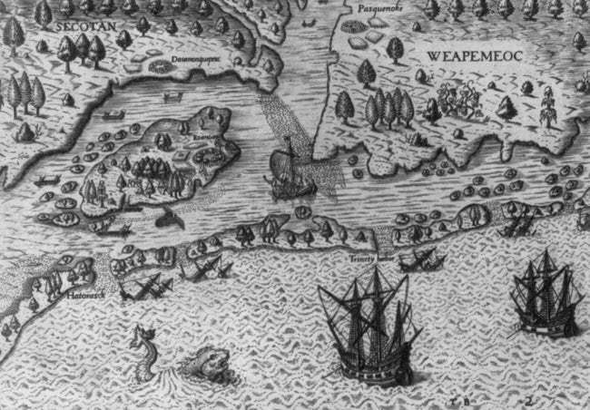Photo: John White/via Wikimedia
The Croatoan tribe believed the island had a spirit who, if angered, had the ability to absorb the offenders into the woods - as in, literally transform them into animals, trees, stones, or anything else in nature. If this lore were taken at face value, that would mean no one went missing, they just became a part of the land.

The Colonists Tried to Sail Back to England
Photo: Internet Archive Book Images/flickr/No known copyright restrictions
It has also been theorized that they grew tired of waiting for John White to return and attempted to sail back to England on their own. Unfortunately, there is no ship, shipwreck, or evidence of any kind to support this theory, either.

The Croatoan Tribe Executed the Colonists as Suspected Witches
Photo: Santiago Camado/via Wikimedia Commons
The Croatoan tribe encountered by the Roanoke colonists believed in witches, both males and females that used black magic to do evil - including, for example, things the colonists may well have been doing, both intentionally and otherwise, including spreading diseases. While the local tribes in that area did not regularly execute witches, there is some precedence for them putting dangerous outsiders to death - and the colonists were nothing if not dangerous outsiders.

